A
Report On
Micro Credit Loan
Use case
For
Telecom Industry

Submitted By:
Rohit Kachhal

ACKNOWLEDGMENT
I would like to express my special gratitude to “Flip Robo” team, who has given me this opportunity to deal with a beautiful dataset and it has helped me to improve my analyzation skills.
A huge thanks to my academic team “Data trained” who are the reason behind what I am doing today.

INTRODUCTION

- Business Problem Framing
- A Microfinance Institution (MFI) is an organization that offers financial services to low income populations. MFS becomes very useful when targeting especially the unbanked poor families living in remote areas with not much sources of income. The Microfinance services (MFS) provided by MFI are Group Loans, Agricultural Loans, Individual Business Loans and so on.
- Many microfinance institutions (MFI), experts and donors are supporting the idea of using mobile financial services (MFS) which they feel are more convenient and efficient, and cost saving, than the traditional high-touch model used since long for the purpose of delivering microfinance services. Though, the MFI industry is primarily focusing on low income families and are very useful in such areas, the implementation of MFS has been uneven with both significant challenges and successes.
- Today, microfinance is widely accepted as a poverty-reduction tool, representing $70 billion in outstanding loans and a global outreach of 200 million clients.
- This use case is for Telecom Industry. They are a fixed wireless telecommunications network provider. They have launched various products and have developed its business and organization based on the budget operator model, offering better products at Lower Prices to all value conscious customers through a strategy of disruptive innovation that focuses on the subscriber.

- Conceptual Background of the Domain Problem
- Telecom industries understand the importance of communication and how it affects a person’s life, thus, focusing on providing their services and products to low income families and poor customers that can help them in the need of hour.
- They are collaborating with an MFI to provide micro-credit on mobile balances to be paid back in 5 days. The Consumer is believed to be defaulter if he deviates from the path of paying back the loaned amount within the time duration of 5 days. For the loan amount of 5 (in Indonesian Rupiah), payback amount should be 6 (in Indonesian Rupiah), while, for the loan amount of 10 (in Indonesian Rupiah), the payback amount should be 12 (in Indonesian Rupiah).

- Motivation for the Problem Undertaken
Based on data provided, customer’s repayment of loan is assessed based on different factors. By building the model, we can access those customers are highly likely to repay the loan, thereby it will be useful for those needy people who will repay the loan and also prevent the loss to the customer by avoiding loans to the defaulters.

Analytical Problem Framing
- Mathematical/ Analytical Modeling of the Problem
In this given dataset, the target variable is ‘label’ which contains two type of value: ‘1’ indicates that the loan has been payed i.e, Non- defaulter while ‘0’ indicates that the loan has not been payed i.e. defaulter. So, this problem is binary classification problem. This classification problem looks like imbalanced. For this problem, I have worked on 8 different classification model of machine learning. This dataset does not contain any null value. It is also observed that some features contain above 92% values as 0, some features contain negative value which is not possible in real world, some are useless columns for model, from one column have to extract data into several column. I used different visualization plot to see the trend of data like distplot to see the distribution and skewness in dataset, boxplot to see the outliers, barplot to see the relationship between target and features, heatmap to see the multicollinearity, ROC AUC curve to see the performance of models. From these plots, I can observe skewness, outliers which I treated accordingly. I have also done hyperparameter tuning on finalize model to improve performance of model but not always hyperparameter tuning improve the performance of model. After that I saved the model and compare the predictions.
- Data Sources and their formats
- DataFrame
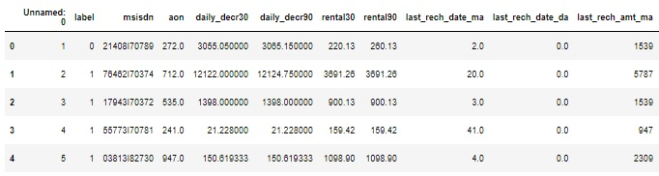
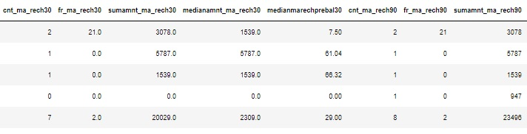

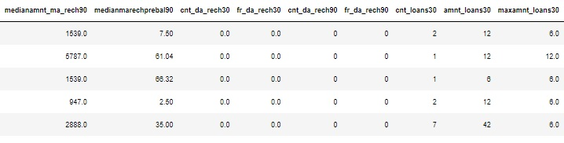

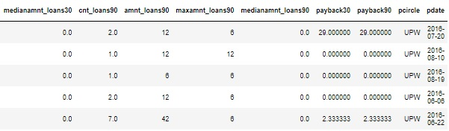

- Outcome:
- This dataframe contains 209593 rows and 37 columns.
- There are no null values in the dataset.
- As data is important so, loss of data above 7-8% is not allowed.

- More about dataset
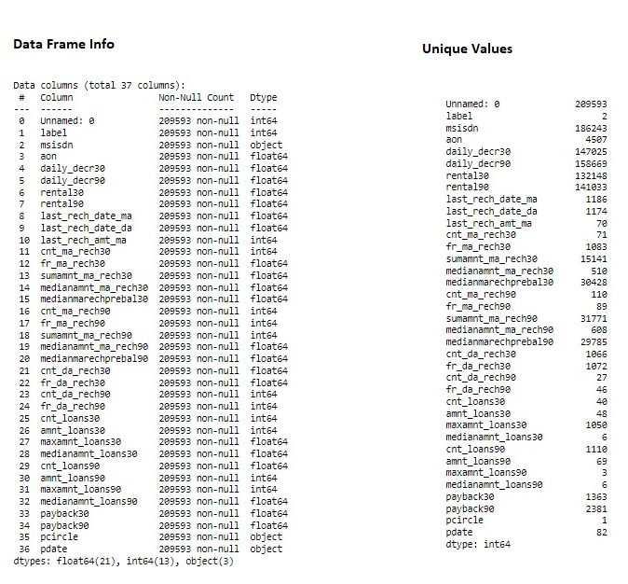
- Descriptive Statistical Analysis
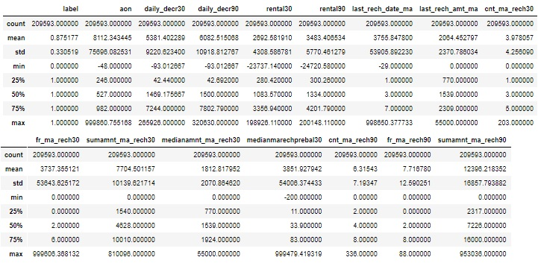
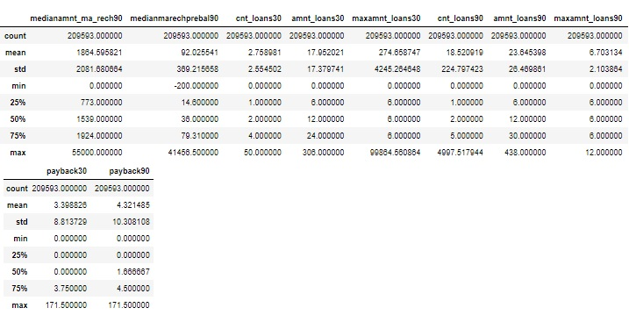
- Outcome:
- Analysis clearly describes the misleading values, Outliers and skewness present in the dataset.

- Data Preprocessing Done
- Some features like age, amount, days contain negative values which is not possible in real world, need to treat them.
- ‘pdate’ contains values in yyyy-mm-dd so, we need to extract day, month and year.
- 'maxamnt_loans30' should be 0,6 and 12. Except these three values, we need to replace rest value by 0.
- Few features contain above 92% value as 0. so, drop these features.
- Drop unwanted columns.
- Dealing with outliers using percentile method.
- Dealing with skewness using ‘yeo-johnson’ method of Power Transformer.

- Data Inputs- Logic- Output Relationships
- I used barplot to visualize the impact of feature on target.
- All data now are of either int or float.
- I observed, in mostly features, customers are Non-Defaulters.
- Defaulters are most in case of 'aon', 'medianmarechprebal30'.

- Hardware and Software Requirements and Tools Used
- Hardware:
- Processor: I3 or above
- RAM: 4 GB or above
- Storage: 250 GB or above
- Software:
- Anaconda
- Jupyter notebook etc
- Libraries:
- numpy
- pandas
- matplotlib
- seaborn
- model_selection: train_test_split, cross_val_score, GridSearchCV
- datetime
- preprocessing : PowerTransformer, StandardScaler,
- imblearn: over_sampling using SMOTE
- metrics: accuracy_score, classification_report, roc_curve, plot_roc_curve, confusion_matrix

Model/s Development and Evaluation

- Identification of possible problem-solving approaches (methods)
First of all, I cleaned the data like treating the values by taking abs() value for those which contains negative value that is not possible in real world domain. After that, extract the value into separate columns from ‘pdate’ using datetime libraries, then replace the value in 'maxamnt_loans30' to 0 if these values are not 0,6 & 1 by using replace().Then, drop those column that contains above 92% value as 0 and those columns which are not useful for model by using drop(). Finally dealing with outliers using percentile method, skewness using ‘yeo-johnson’ method of Power Transformer and imbalancing using over_sampling of SMOTE algorithm.

- Testing of Identified Approaches (Algorithms)
As the problem is binary classification problem. In machine learning there are several algorithms for classification problem. I used total 8 algorithm to build best model on this dataset. The algorithms are:
- Logistic Regression
- K-Neighbors Classifier
- Decision Tree Classifier
- Random Forest Classifier
- Bagging Classifier
- Gradient Boosting Classifier
- AdaBoost Classifier
- XGB Classifier

- Run and Evaluate selected models
Here are the coding and insights of all models:
- Logistic Regression
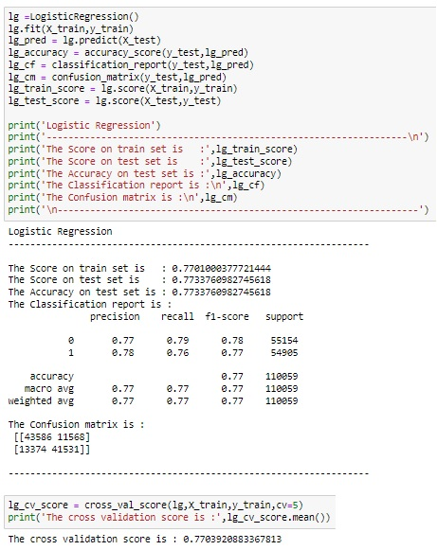

- K-Neighbors Classifier
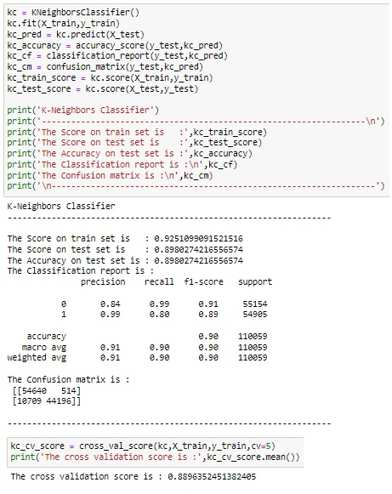

- Decision Tree Classifier
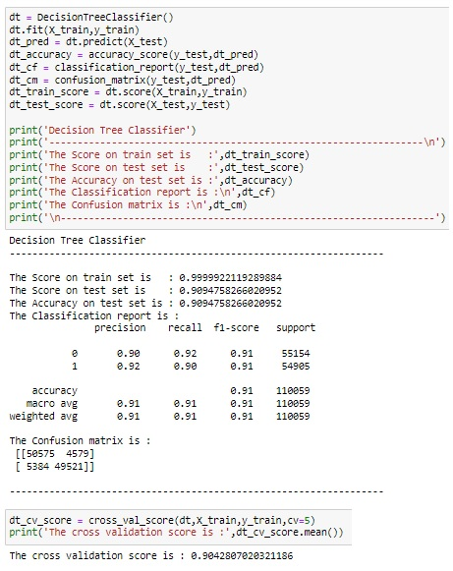

- Random Forest Classifier
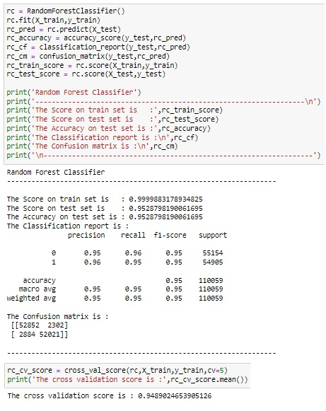
- Bagging Classifier
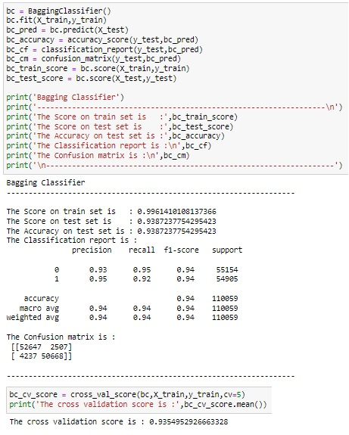
- Gradient Boosting Classifier
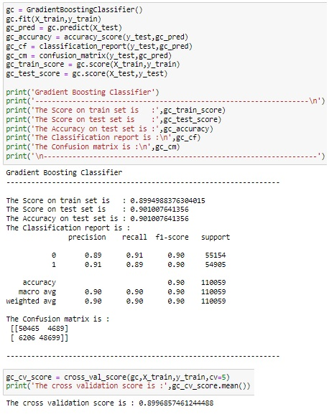
- AdaBoost Classifier
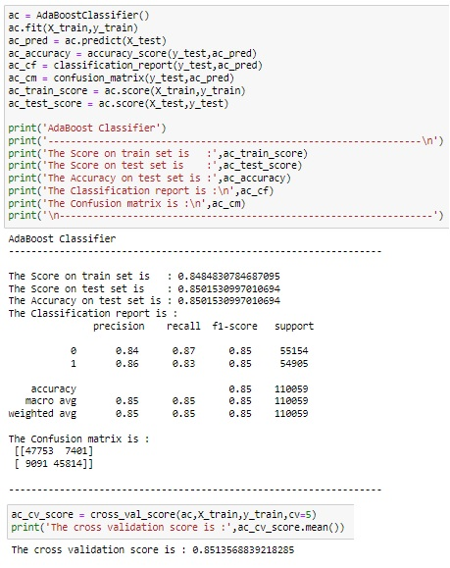

- XGB Classifier
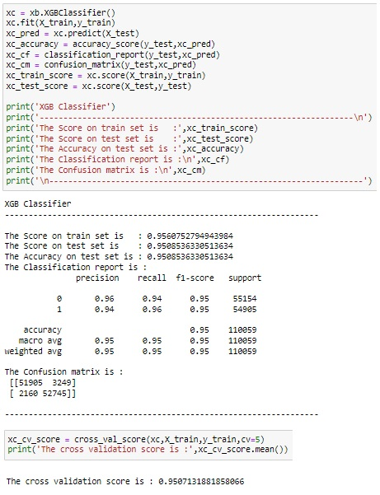

- Key Metrics for success in solving problem under consideration
Following are the metrics to observe good model:
- Accuracy simply measures how often the classifier correctly predicts. Accuracy can be defined as the ratio of the number of correct predictions and the total number of predictions.
- Precision explains how many of the correctly predicted cases actually turned out to be positive. Precision is useful in the cases where False Positive is a higher concern than False Negatives.
- Recall explains how many of the actual positive cases we were able to predict correctly with our model. It is a useful metric in cases where False Negative is of higher concern than False Positive.
- It gives a combined idea about Precision and Recall metrics. It is maximum when Precision is equal to Recall.
- Cross_val_score: Cross-validation is a resampling method that uses different portions of the data to test and train a model on different iterations. It is mainly used in settings where the goal is prediction, and one wants to estimate how accurately a predictive model will perform in practice.
- AUC-ROC: The Receiver Operator Characteristic (ROC) is a probability curve that plots the TPR(True Positive Rate) against the FPR(False Positive Rate) at various threshold values and separates the ‘signal’ from the ‘noise’.
- AUC is the measure of the ability of a classifier to distinguish between classes.

- Visualizations
- Univariate
- Using distplot checking distribution
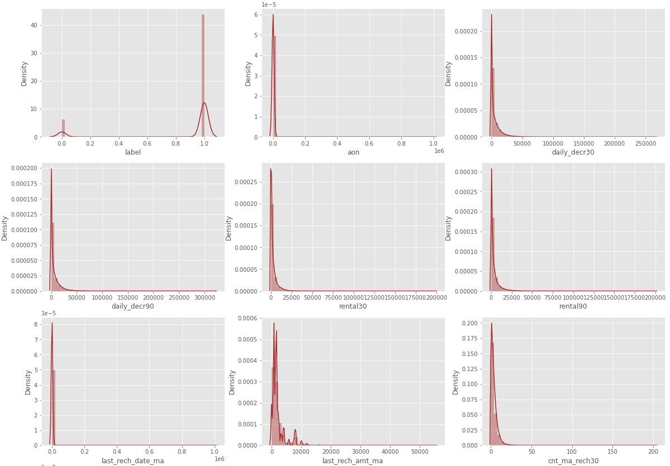
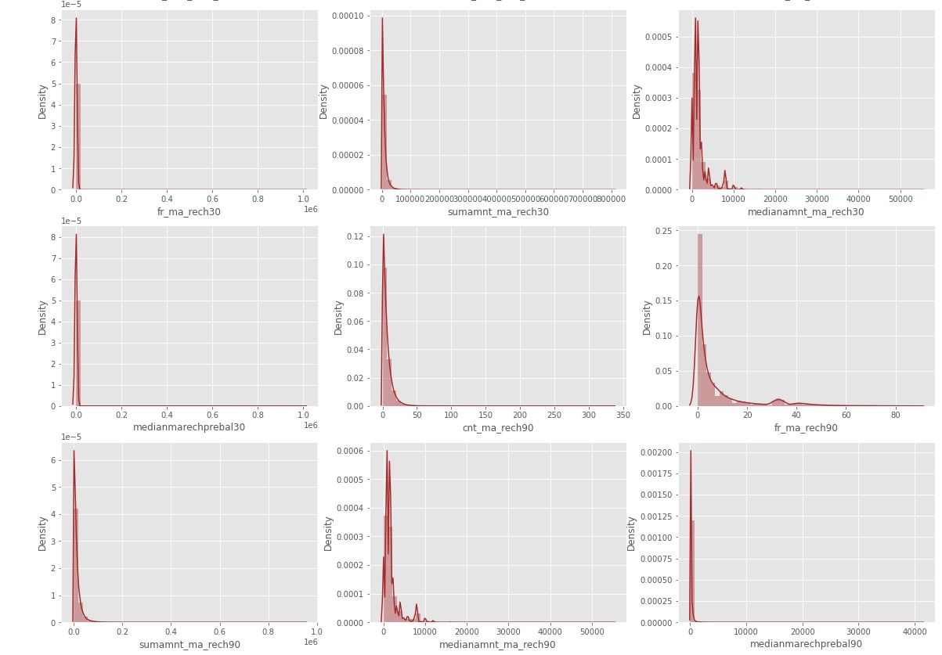

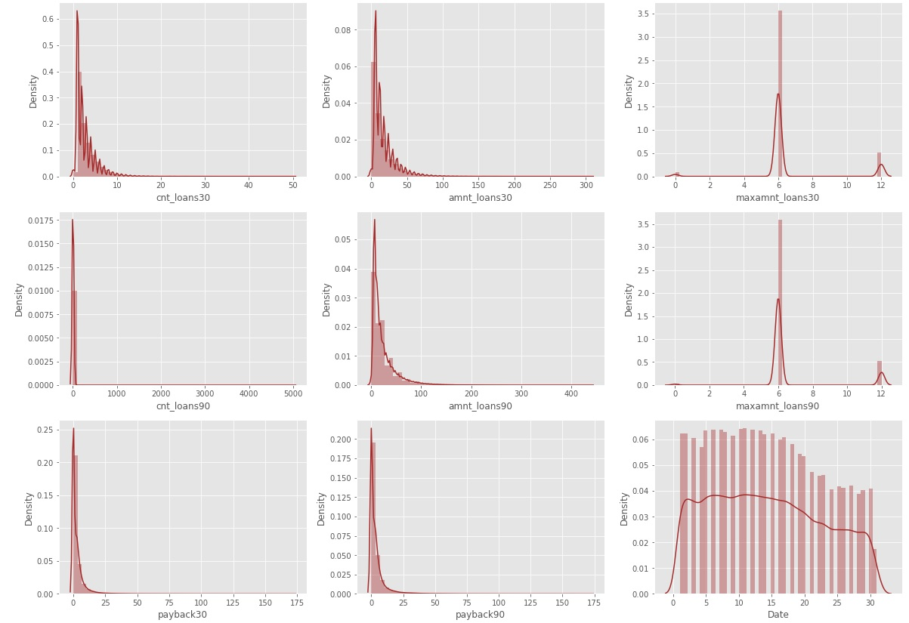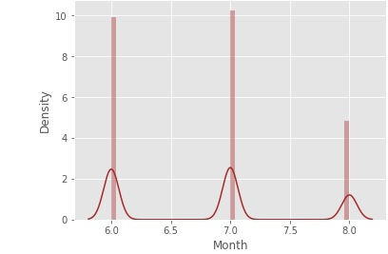
- Using boxplot checking outliers
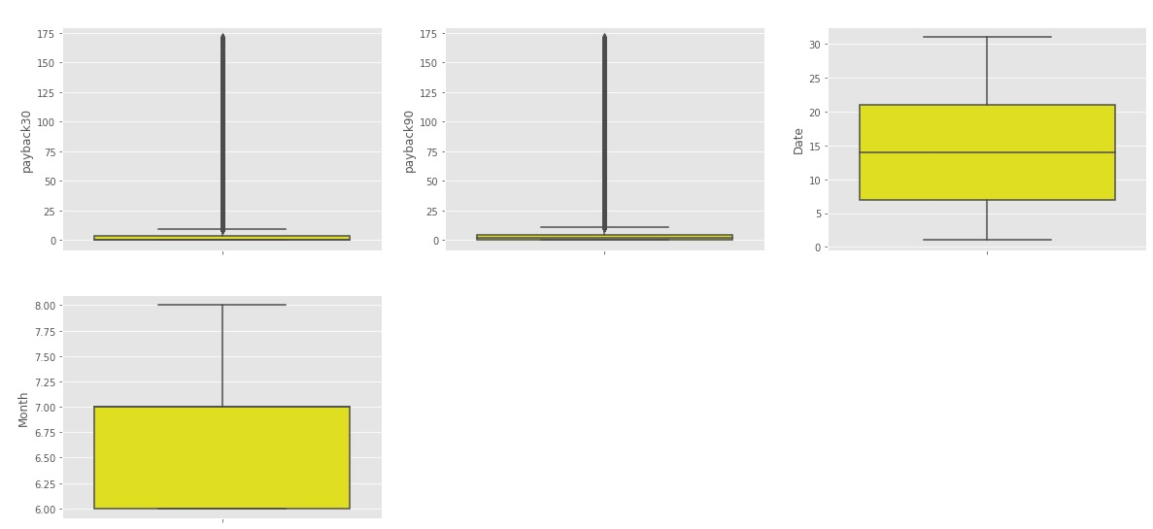
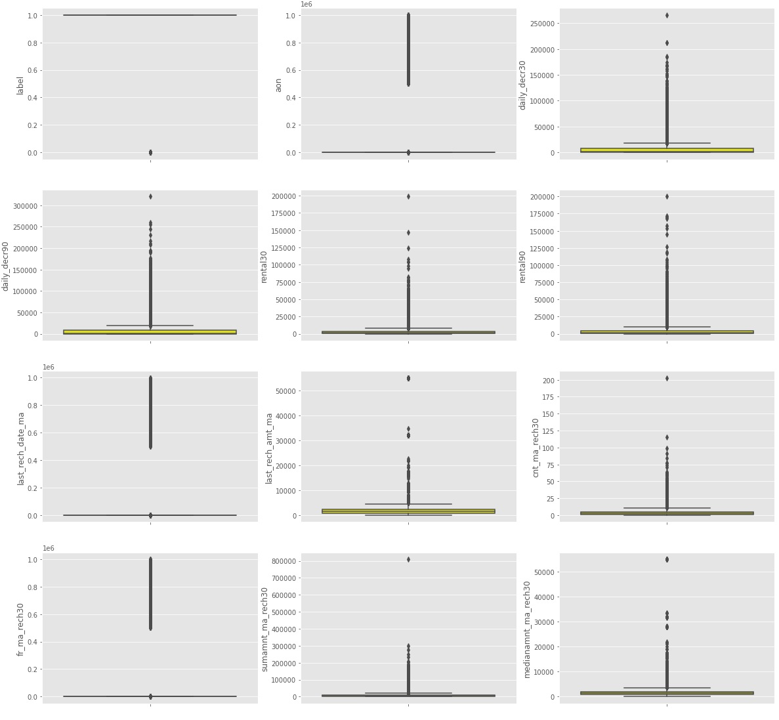
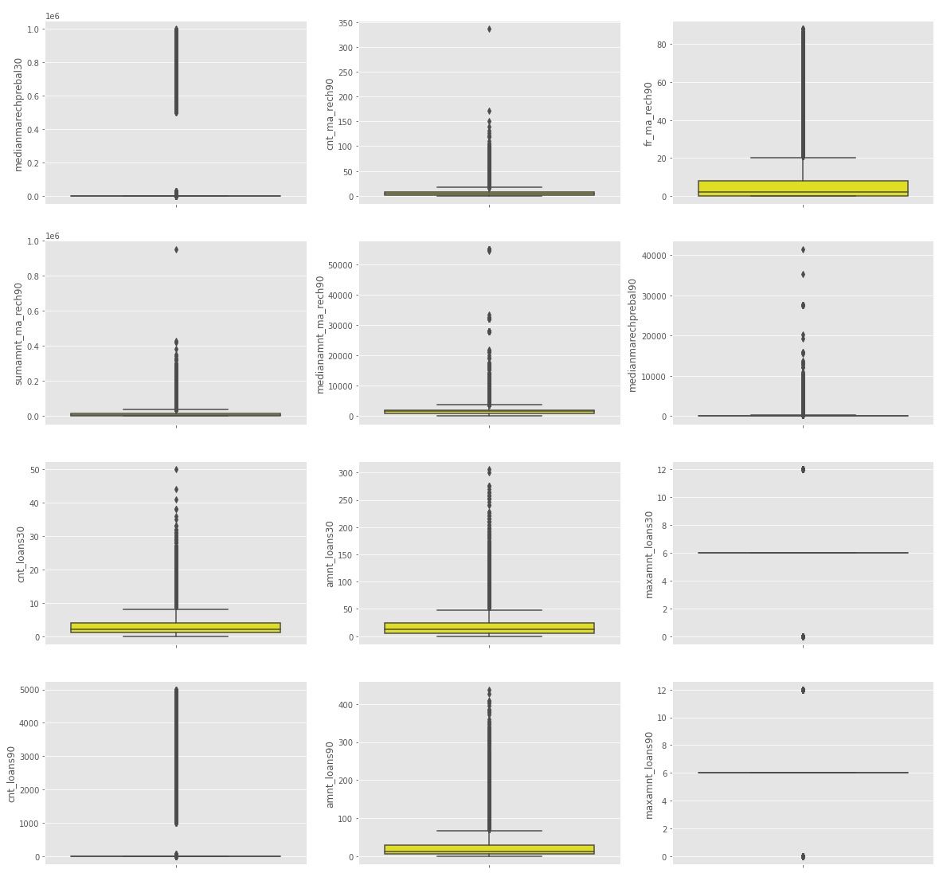

- Visualize target

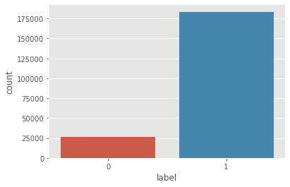
- Outcome:
- Skewness is there
- Outliers is there
- Target is imbalance

- Bivariate

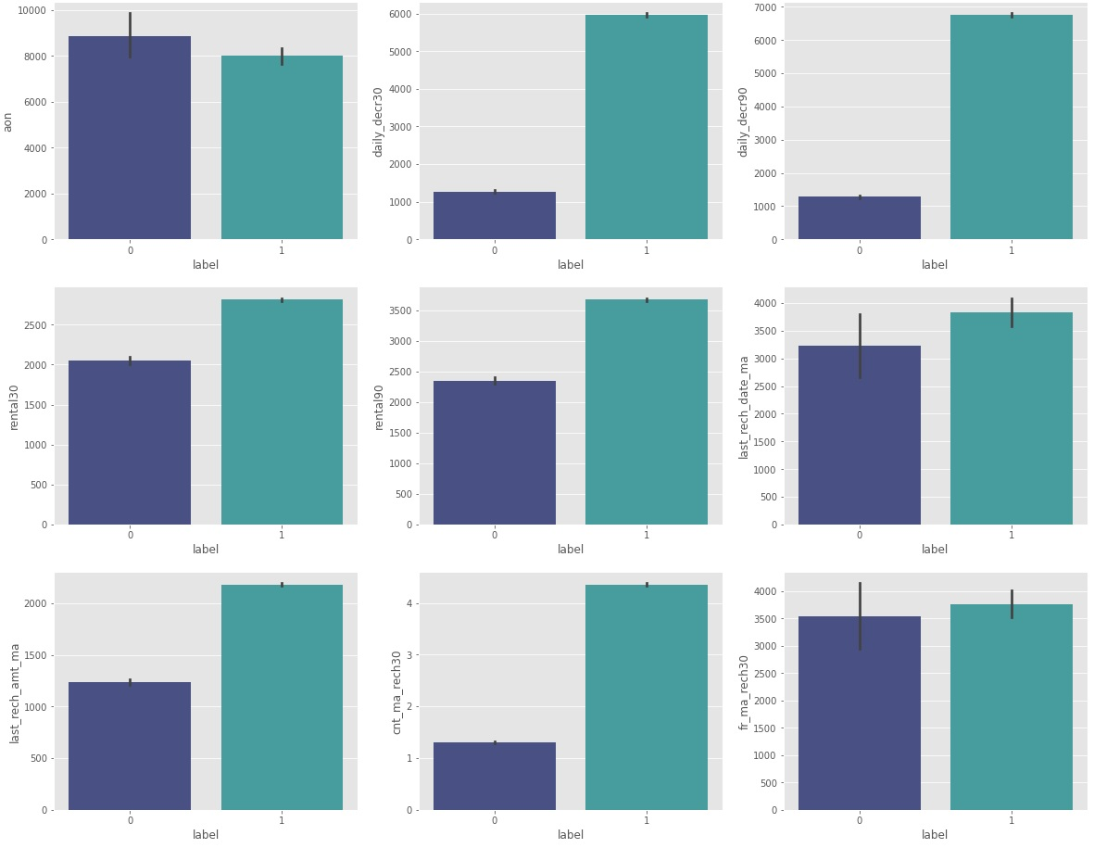

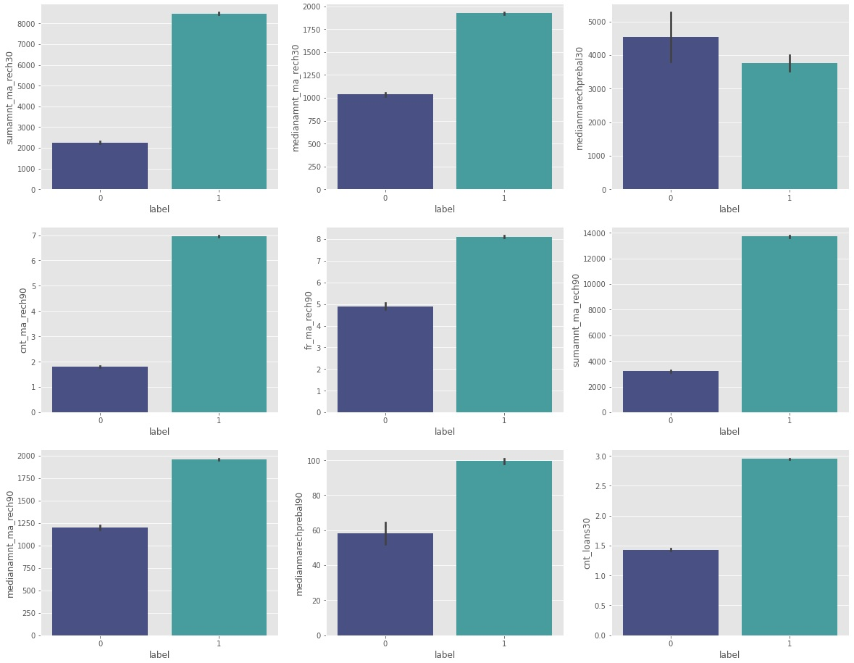
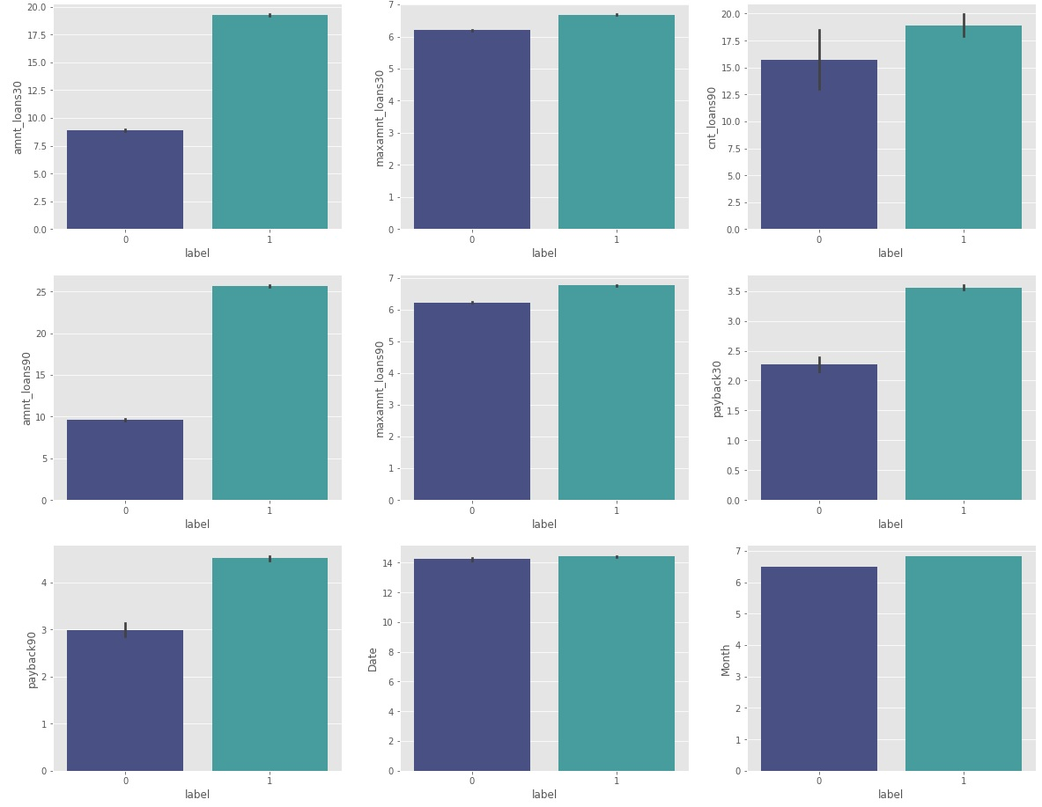
- Outcome
- Defaulters are more in case of 'aon','medianmarechprebal30'.
- Non-Defaulters are more in case of 'daily_decr30','daily_decr90','rental30', 'rental90','last_rech_date_ma','last_rech_amt_ma','cnt_ma_rech30', 'fr_ma_rech30','sumamnt_ma_rech30','medianamnt_ma_rech30', 'cnt_ma_rech90','fr_ma_rech90','sumamnt_ma_rech90', 'medianamnt_ma_rech90','medianmarechprebal90','cnt_loans30', 'amnt_loans30', 'maxamnt_loans30', 'cnt_loans90','amnt_loans90', 'maxamnt_loans90', 'payback30','payback90','Date','Month'.

- Correlation matrix

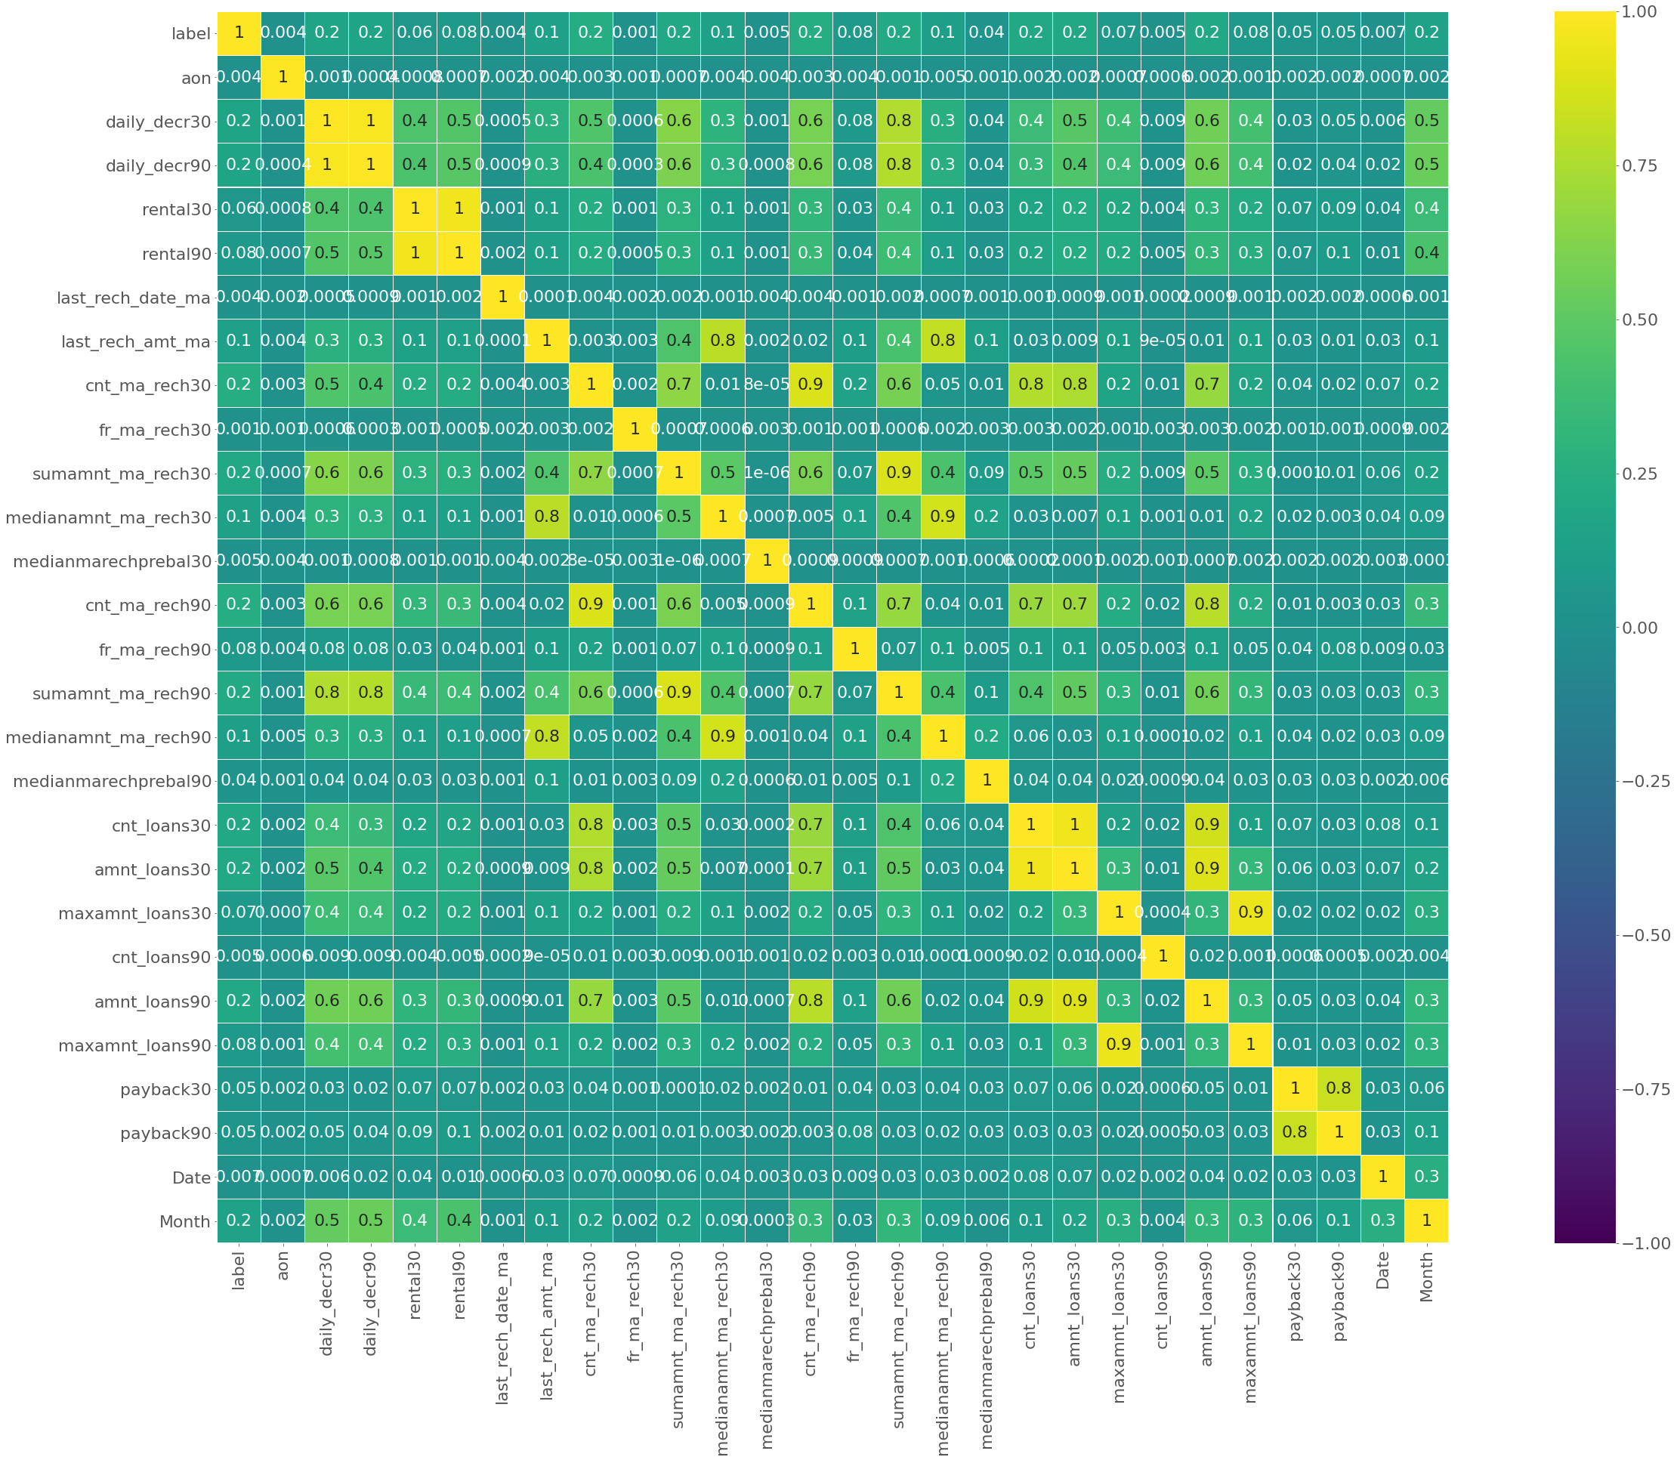
- Outcome:
- All features are vrey less correlated with target.

- Interpretation of the Results

- ROC-AUC Curve
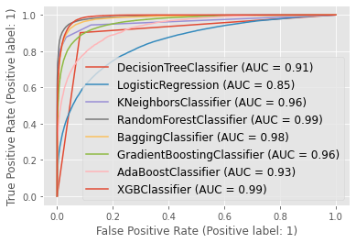
- Outcome:
- XGB Classifier & Random Forest Classifier have best score.

- Score of all model
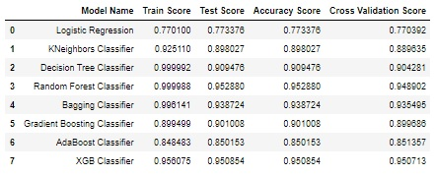
- Outcome:
- The difference between accuracy score and cross validation score is less for XGB Classifier as compared with Random Forest Classifier. So, XGB Classifier is final model on this dataset.

- Hyperparameter Tuning
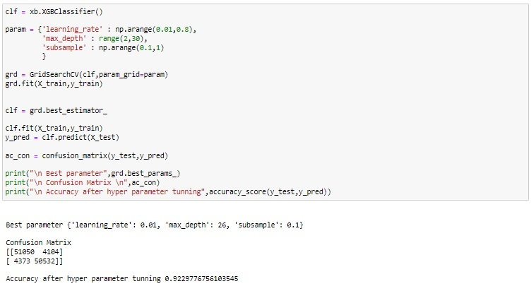

- Outcome:
- After hyperparameter tuning, not able to improve performance. So, default parameters are best parameters.

CONCLUSION
- Key Findings and Conclusions of the Study
Mostly, the customers have the intension of repaying. There are certain cases when the customers have no intension of repayment but the number of such customers are few. With the model built, we can certainly determine those customers having intension of repayment or not.

- Learning Outcomes of the Study in respect of Data Science
- The dataset was full of outliers, skewness and unbalanced data which was the biggest challenge to overcome. Hence, data cleaning was very important to get proper prediction.
- While removing the outliers, in most of the scenarios Z-score was used as outlier removal technique since it performs quite well with less data loss. In this dataset major challenges was using IQR & zscore the loss of data is above the criteria so I used percentile method.

- Limitations of this work and Scope for Future Work
- The solution can be applied to the customer having a transaction history but the model may not perform well with customer having new profile and no transaction history. Nevertheless, the model will perform well with customer having transaction history and can predict whether a person will be a defaulter or non-defaulter.
- This data set contains data of the year 2016 belonging to PSW telecom circle.If we get data of other years along with other telecom companies we can predict on varied scenario.

